NEWCOMER APPRECIATION

SPEAKER JAM

*“We Are Not A Drug Specific Fellowship”*

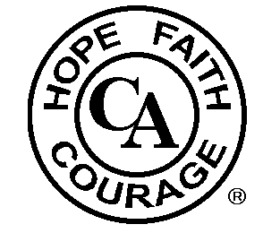

SATURDAY, OCTOBER 28, 2023

AKRON PUBLIC LIBRARY AUDITORIUM

60 S. HIGH ST.

AKRON, OH 44308

11:00 A.M. TO 4:00 P.M.

FOOD AVAILABLE FOR SALE

FOR MORE INFO CONTACT TERRY D. 330-283-4105

Helpline 330-375-0775 CAOHIO.ORG

In the spirit of Tradition 6 we are not allied with any sect, denomination, politics, organization or institution.